Ronney Aovida Lab 1 for ISC4232 Continuous methods

Question 2: * For question 2 code please refer to lab1Q2.m *

Part a) (a) Explain why each point on the real axis converges to z1.

**Answer:** each point on the Real axis converges to z1 because using newtons method on the function f(z)=Z^3 -1 we will find that most solutions will come to convergence with z1=1 rather than the alternative z2 and z3 of which lay in the complex plane in the grid, meaning that not all real numbers are in their domain.

(b) Describe what happens when an initial guess of z [0] = 0 is used.

**Answer**: in the following newtons method equation:

z(n+1)=z(n)-(f(x))/f'(x)

z(n+1)=z(n)-(n(n)^3 -1)/(3*z(n)^2 , when the value at z(n)=0 then no

solution can be found since this will involve dividing by 0 in the

denominator.

(c) Below is the figure generated for part (c). This figure depicts the Basin of attraction.

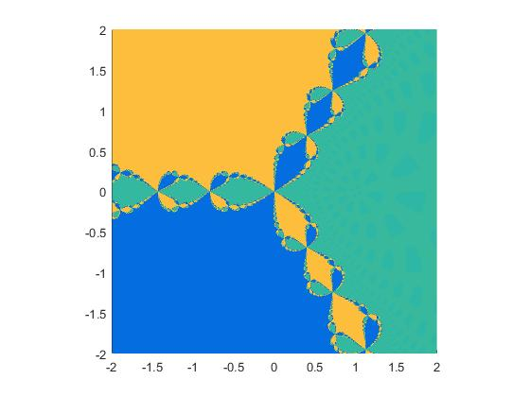

Question 3:

a) D(theta)= (r1(theta)-x1 )^2 + (r2(theta)-x2 )^2 =0

b) D'(theta)= (2*(r1(theta)-x1 )* r1'(theta) ) + ( 2*(r2(theta)-x2 )* r2'(theta) )=0

c) D'(theta)= 2*(cos(theta)-x1 )* -sin(theta) + 2*(sin(theta)-x2 )*cos(theta)=0

this should provide 4 solutions because cos and sin are seen as a

parameterization of the unit circle at 0, pi/2, pi and 3pi/2.

* See Lab1Q3.m for part (d), (e) and (f) *

part (f):

According to the graph in part (e) I have found the basin of attraction is

from the range of -0.75 to 2. my estimated interval would be [-0.75,2].